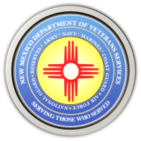

Michelle Lujan Grisham Governor
Sonya L. Smith Cabinet Secretary

A Memorial Day Video Message From
DVS Cabinet Secretary Sonya Smith

Here is a link to a brief Memorial Day video message from DVS Cabinet Secretary Sonya Smith.

https://www.youtube.com/watch?v=-CYUlYR8iSA

