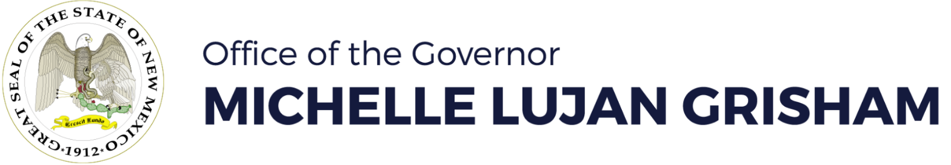

**FOR IMMEDIATE RELEASE**

**Contact:** Stacy Johnston

Department of Workforce Solutions

[stacy.johnston@state.nm.us](mailto:stacy.johnston@state.nm.us)

May 16, 2022

**Disaster Unemployment Assistance opens for New Mexicans affected by wildfires**

*DUA part of disaster declaration assistance secured by governor*

ALBUQUERQUE – At the request of Governor Michelle Lujan Grisham, President Biden has authorized federal disaster aid for the State of New Mexico, making Disaster Unemployment Assistance (DUA) available to New Mexicans whose employment or self-employment was lost or interrupted as a direct result of the 2022 Wildfires.

New Mexicans can now apply for DUA at various evacuation shelters, at any Workforce Connection Center across the state, or by calling the Unemployment Insurance Operations Center at 1-877-664-6984, 7 a.m.-4:30 p.m. Monday through Friday. ***The deadline to apply is June 15, 2022.***

Applications filed after the deadline may be denied unless the individual provides good cause for filing after that date; therefore, claimants should file as soon as possible.

DUA is available to individuals who:

* Worked or were self-employed or were scheduled to begin work or self-employment; and
* Do not qualify for regular unemployment benefits, or Extended Benefits (EB) from any state; and
* Were unable to reach their job or self-employment location because they must travel through the affected area and are prevented from doing so by the disaster; or
* Can no longer work or perform services because of physical damage or destruction to the place of employment as a direct result of the disaster; or
* Cannot physically access the place of employment due to its closure by the federal, state, or local government in immediate response to the disaster; or
* Can establish that the work or self-employment they can no longer perform was their principal source of income; or
* Cannot perform work or self-employment because of an injury as a direct result of the disaster; or
* Became the breadwinner or major support of a household because of a death related to the disaster/fire.

Proof of employment/self-employment must be submitted no later than 21 days after filing for a DUA claim. The following documents are acceptable as proof of employment:

* Payroll voucher or check stub closest in date to the last work week
* Employment and earnings statement from employer with name, address and contact information
* Written statement from employer
* Business records (bank statements, business receipts, licenses, advertisements, invoices, appointment books, financial statements)

DUA is available for weeks of unemployment beginning April 10, 2022 until November 5, 2022, as long as the individual’s unemployment continues to be a direct result of the disaster.

DUA applications are only being accepted in person or by phone. Eligible claimants may receive their benefits via direct deposit or debit card.

**In-Person Locations to File a DUA Claim**

Individuals who are applying in-person for DUA may go to any New Mexico Workforce Connection office (<https://www.dws.state.nm.us/Office-Locations>) or to one of the locations listed below, 9 a.m.-4 p.m. Monday through Friday.

**Glorieta Camp**

11 NM-50, Glorieta, NM 87535

**Juan Gonzales Agriculture Center**

202 Chamisa Road, Taos, NM 87571

**Old Memorial Middle School**

947 Old National Rd, Las Vegas, NM 87701

All New Mexicans affected by the wildfires are urged to register for FEMA individual assistance at [www.disasterassistance.gov](http://www.disasterassistance.gov).