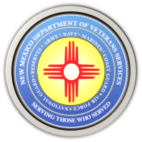

Michelle Lujan Grisham Governor
Sonya L. Smith Cabinet Secretary

DVS Joins Effort to Restore Albuquerque Historic Fairview Cemetery

Here is a link to the day the New Mexico Department of Veterans Services (DVS) joined the effort by volunteers to restore the Albuquerque Historic Fairview Cemetery.

The cemetery closed in 2012 and has fallen into a severe state of disrepair. After learning that more than 5,000 veterans are buried here—some from as far back as the Civil War—DVS has agreed to join the all-volunteer cleanup effort.

https://www.youtube.com/watch?v=YSFFnAmwpBg

