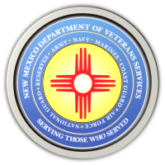

Michelle Lujan Grisham Governor
Sonya L. Smith Cabinet Secretary

March 29, 2022

DVS to Give Agency/Veterans Issues Briefing
on March 31 in Albuquerque

New Mexico Veterans Memorial (9am-Noon)
1100 Louisiana Blvd. SE

(ALBUQUERQUE)— The New Mexico Department of Veterans Services (DVS) will provide an update on the latest agency and veterans issues on March 31 from 9am-noon in Albuquerque for presidents, commanders, representatives of veteran and community service organizations, and any interested veterans.

This quarterly briefing will be at the New Mexico Veterans Memorial, located at 1100 Louisiana Boulevard SE.

For more information, contact DVS Public Information Officer Ray Seva at ray.seva@state.nm.us or (505) 362-6089.

###
The New Mexico Department of Veterans Services
The New Mexico Department of Veterans Services (DVS) provides support and services to New Mexico’s 151,000 veterans and their families. DVS treats every veteran, regardless of their rank achieved during military service, with the respect and gratitude befitting someone who has served our country. We strive every day to live up to our agency’s official motto: Serving Those Who Served

