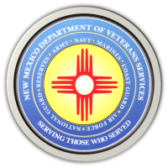

The New Mexico Department of Veterans Services
Michelle Lujan Grisham Governor
Sonya L. Smith Cabinet Secretary

January 12, 2022

DVS Postpones All In-Person
Agency Events & Outreach Visits

SANTA FE-The New Mexico Department of Veterans Services (DVS) has postponed all scheduled January and February in-person agency events and outreach visits due to the continuing high rates of New Mexicans testing positive for COVID-19.

Barring additional COVID-19 developments, DVS hopes to reschedule the postponed events beginning in March and will send notifications about re-scheduled dates.
In-office visits to all DVS field offices will continue on an appointment-only basis. Appointments can be made by contacting DVS veterans service officers (VSO) listed on DVS website: https://www.nmdvs.org/new-mexico-offices/

All DVS VSOs are also continuing to offer remote benefits assistance by phone or email. Any veteran from anywhere in New Mexico can contact any VSO for assistance.

You can also contact DVS at (505) 383-2400 or nmdvs.info.state.nm.us

###

