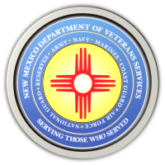
The New Mexico Department of Veterans Services

Michelle Lujan Grisham Governor
Sonya L. Smith Cabinet Secretary

FOR IMMEDIATE RELEASE
Contact: Ray Seva
DVS Public Information Officer
ray.seva@state.nm.us
(505) 362-6089

Link to Video Highlights of the 2021 Veterans Day Ceremony in Santa Fe

SANTA FE-The New Mexico Department of Veterans Services (DVS) has produced a video highlighting the 2021 Veterans Day Ceremony in Santa Fe.
https://www.youtube.com/watch?v=A9BR6OjAoe0

###

The New Mexico Department of Veterans Services
The New Mexico Department of Veterans Services (DVS) provides support and services to New Mexico’s 151,000 veterans and their families. DVS treats every veteran, regardless of their rank achieved during military service, with the respect and gratitude befitting someone who has served our country. We strive every day to live up to our agency’s official motto: Serving Those Who Served

