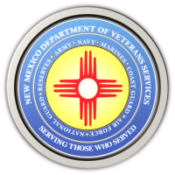
The New Mexico Department of Veterans Services

Michelle Lujan Grisham Governor
Sonya L. Smith Cabinet Secretary

ALBUQUERQUE-The New Mexico Department of Veterans Services (DVS), the New Mexico National Guard, and AARP-New Mexico hosted the 2021 New Mexico Honor Guard Training Conference on September 30 in Albuquerque.

Honor guards render military honors at the funerals of fallen service members and deceased veterans. All-volunteer honor guards perform the bulk of this duty in New Mexico.

The annual training conference at the New Mexico Veterans Memorial provides an opportunity for the honor guards to receive training from a New Mexico National Guard Honor Guard, and perform a simulated military funeral in front of judges.

Here is a link to a video produced by DVS that highlights the demonstration by the NMNG Honor Guard, and the performances by the volunteer honor guards.
https://www.youtube.com/watch?v=hHJC2VDI7us.

The New Mexico Department of Veterans Services
The New Mexico Department of Veterans Services (DVS) provides support and services to New Mexico’s 151,000 veterans and their families. DVS treats every veteran, regardless of their rank achieved during military service, with the respect and gratitude befitting someone who has served our country. We strive every day to live up to our agency’s official motto: Serving Those Who Served.

###

