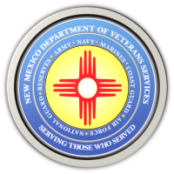
The New Mexico Department of Veterans Services

Michelle Lujan Grisham Governor
Sonya L. Smith Cabinet Secretary

FOR IMMEDIATE RELEASE
Contact: Ray Seva
DVS Public Information Officer
ray.seva@state.nm.us
(505) 362-6089

DVS Produces a Video Highlighting the
2021 Forgotten Heroes Funeral

The New Mexico Department of Veterans Services (DVS) has produced a video highlighting the September 23 Forgotten Heroes Funeral at the Santa Fe National Cemetery--the annual military funeral for veterans, who upon death in New Mexico, are unclaimed by family for burial.
Here is the link to the video. https://www.youtube.com/watch?v=0TSaTgXGRHE

This year, 22 unclaimed deceased veterans were laid to rest. Governor Michelle Lujan Grisham delivered the eulogy. New Mexico Army National Guard Maj. Gen. Ken Nava, the adjutant general of New Mexico, read a roll call of the names of the deceased veterans shortly before their cremated remains were buried.
The Forgotten Heroes Funeral Program is presented by DVS, the New Mexico National Guard, Bernalillo County, the state office of the medical investigator, and Daniels Family Funeral Services of Albuquerque. It was the first state-sponsored program in the nation to ensure that honorably discharged deceased veterans are not forgotten in the end—and will be given the “final salute” veterans have earned through their service for our country.

###

