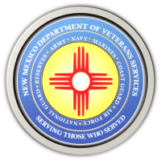
The New Mexico Department of Veterans Services

Michelle Lujan Grisham Governor
Sonya L. Smith Cabinet Secretary

FOR IMMEDIATE RELEASE
Contact: Ray Seva
DVS Public Information Officer
ray.seva@state.nm.us
(505) 362-6089

Statement From DVS Secretary Sonya L. Smith
Regarding the Passing of Former U.S. Army General/Secretary of State Colin Powell

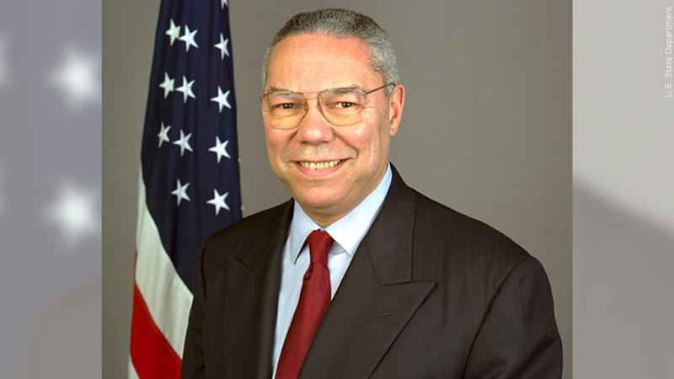

I am deeply saddened over the passing today of retired U.S. Army General Colin Powell.

General Powell was a military and public servant pioneer. After serving two tours of duty in Vietnam—he became the youngest and first African American appointed as national security advisor when tapped for the position in 1987 by President Ronald Reagan. Two years later, he was the first African American appointed as chairman of the Joint Chiefs of Staff—a position he served under President George H.W. Bush through the Gulf War. In 2001, General Powell then became the first African American to be named Secretary of State when President George W. Bush appointed him to the position.
In 1991, I was an Air Force Reserve medic deployed during Desert Shield/Desert Storm to Oman. General Powell was serving as the chief military strategist for the Gulf War operations. As a military service member, I appreciated his leadership and devotion to the men and women under his charge. He was a calming voice during tense and uncertain times. As the first African American appointed as Cabinet Secretary for the New Mexico Department of Veterans Services by Governor Michelle Lujan Grisham, I stand on his shoulders. I admired him for his groundbreaking achievement up the military chain of command and, later, in public office.

General Powell was truly one of a kind. I salute him one last time…and offer my condolences to his family during their time of grief.

Sonya L. Smith
Cabinet Secretary,
New Mexico Dept. of Veterans Services.

###

The New Mexico Department of Veterans Services
The New Mexico Department of Veterans Services (DVS) provides support and services to New Mexico’s 151,000 veterans and their families. DVS treats every veteran, regardless of their rank achieved during military service, with the respect and gratitude befitting someone who has served our country. We strive every day to live up to our agency’s official motto: Serving Those Who Served

