The New Mexico Department of Veterans Services

Michelle Lujan Grisham Governor
Sonya L. Smith Cabinet Secretary

FOR IMMEDIATE RELEASE
Contact: Ray Seva
DVS Public Information Officer
ray.seva@state.nm.us
(505) 362-6089

More than 800 Memorial Bricks Placed on the Grounds of the Vietnam Veterans Memorial in Angel Fire

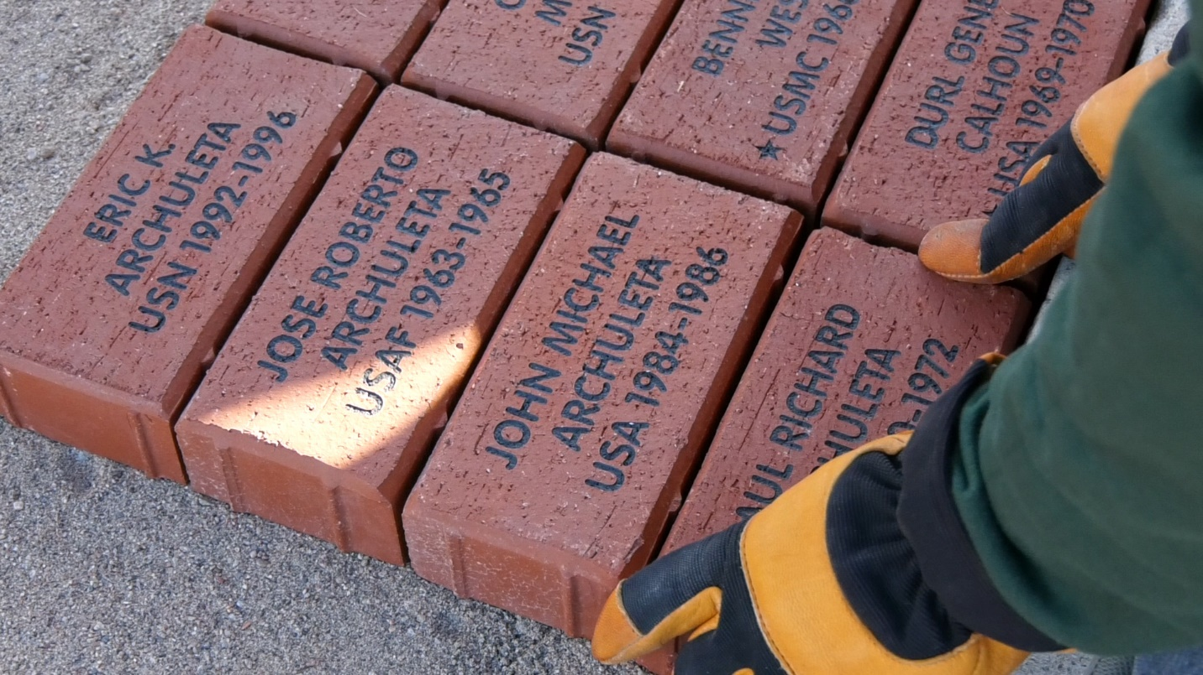

ANGEL FIRE- More than 800 veterans memorial bricks were placed on the grounds of the Vietnam Veterans Memorial in Angel Fire today during an annual Labor Day weekend bricklaying.

The red bricks were purchased by anyone wanting to honor a military service member or veteran--living or deceased. Each brick bears the name of the veteran or service member, his or her branch of service, and the years served. Bricks with no end date indicate an active-duty service member. Bricks with one star indicates the service member is still classified by the U.S. Department of Defense as missing in action. Two stars indicate the service member was killed in action.

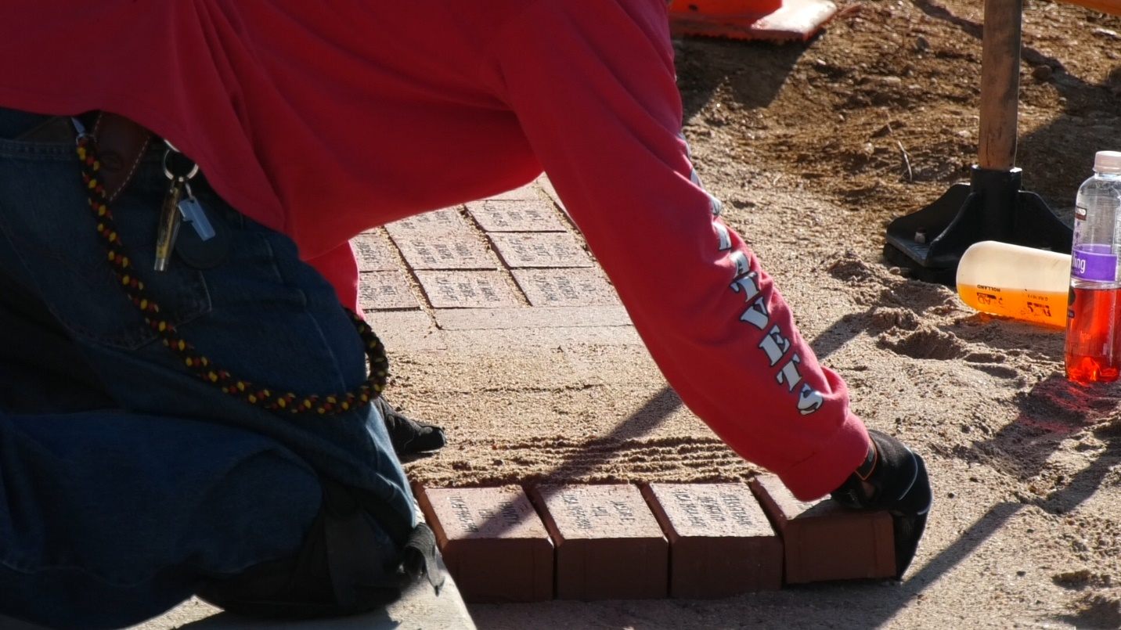More than one hundred volunteers placed the bricks along the sidewalks of the memorial grounds. Most volunteers were members of the Run For The Wall Foundation—a veterans service group that supports active-duty service members, while also honoring the memory of those killed in action, and calling for a full accounting of those still missing in action.

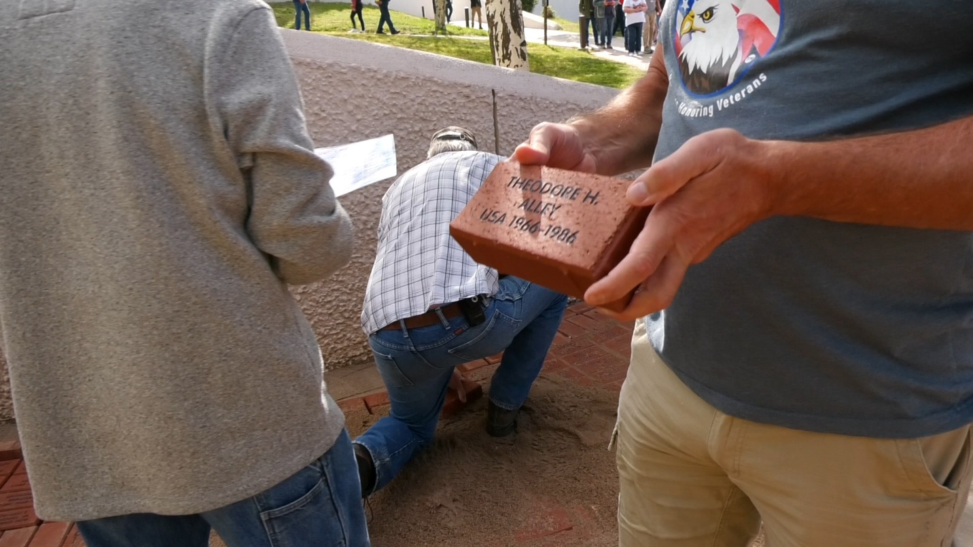
The group hosts an annual springtime motorcycle ride that begins in Southern California and ends at the National Vietnam Veterans Memorial in Washington, D.C. on Memorial Day weekend. The annual bricklaying event at the Angel Fire memorial, which since 2017 has been managed by the New Mexico Department of Veterans Services (DVS), serves as a reunion for the riders.

“As an Army veteran, today is an emotional, very touching day for me,” said DVS Deputy Secretary Bryan Osterhage, who attended the event—his first since being appointed deputy secretary in 2019. “It makes me proud that we (DVS) are able to host the event—and know that veterans are forever honored here at this beautiful place.”

Last year’s bricklaying was cancelled due to the height of the COVID-19 pandemic.The more than 800 bricks placed this year far surpasses the typical 450-500 brick placed every year.

For more information about purchasing memorial bricks for next year, please contact the Vietnam Veterans Memorial at (575) 377-2293.

###

