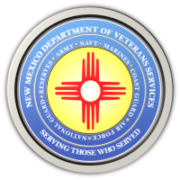
The New Mexico Department of Veterans Services

Michelle Lujan Grisham Governor
Sonya L. Smith Cabinet Secretary

FOR IMMEDIATE RELEASE
Contact: Ray Seva
DVS Public Information Officer
ray.seva@state.nm.us
(505) 362-6089

DVS Postpones Next Week’s
2021 Honor Guard Training Conference

SANTA FE— The New Mexico Department of Veterans Services (DVS) has postponed the 2021 Honor Guard Training Conference scheduled for August 19 in Albuquerque.

The postponement is a safety precaution in light of increasing COVID-19 cases from across the state.
“We hope our veterans and honor guards understand our decision to postpone this conference,” said DVS Secretary Sonya L. Smith. “DVS remains vigilant in keeping our veterans and DVS staff safe from this virus. We cannot ease up in our fight.”

DVS may reschedule the conference once the rates decrease, and will alert the veteran community if/when this happens.

The New Mexico Department of Veterans Services
The New Mexico Department of Veterans Services (DVS) provides support and services to New Mexico’s 151,000 veterans and their families. DVS treats every veteran, regardless of their rank achieved during military service, with the respect and gratitude befitting someone who has served our country. We strive every day to live up to our agency’s official motto: Serving Those Who Served. For help here in New Mexico, contact us at (505) 383-2400 or nmdvs.info@state.nm.us to be put in touch with a DVS veterans service officer who can help you and your family.

###

