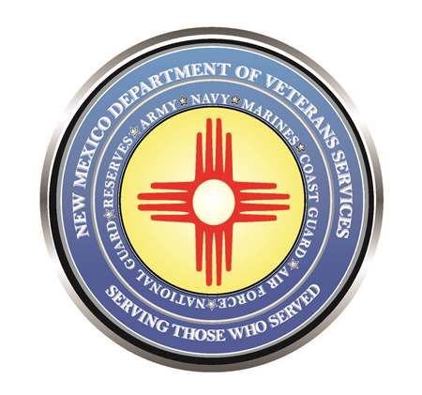

Michelle Lujan Grisham
Governor

Judy M. Griego
Cabinet Secretary

Briefing/Orientation for Agencies Interested in Booth/Table Space for 2021 Military & Veterans Day at the State Fair

Thursday, July 8 (2pm)
Albuquerque
New Mexico State Fairgrounds/Manuel Lujan Exhibit Complex Bldg. C
300 San Pedro Drive NE

(ALBUQUERQUE, NM)— Veterans and community service organizations interested in registering for a table/booth space for 2021 Military & Veterans Appreciation Day at the State Fair are invited to attend a 2pm orientation & briefing on Thursday, July 8 in Albuquerque at the New Mexico State Fairgrounds/Manuel Lujan Exhibit Complex/Bldg. C.

The state fairgrounds is located in Albuquerque at 300 San Pedro Drive NE. Parking will be provided at the San Pedro Gate #3. Anyone unvaccinated for COVID-19 will be required to wear safety masks for the orientation/briefing.

Military & Veterans Day at the State Fair is September 14 at the state fairgrounds. Online registration for booths/tables is now open via https://statefair.exponm.com/p/things-to-do/mainstreet/application-sept-14.

The July 8 briefing provides an in-person registration opportunity, and hear from state fair officials about rules regarding parking, table/booth size, setup and breakdown, available electrical outlets/power, and other regulations for setting up displays during 2021 state fair—which runs from September 9-19.

There is a limited amount of space allotted for displays on Main Street. The deadline for online registration is Monday, August 16, at 5pm. Applications will then be selected at random to ensure an equal chance for all applicants. Organizations that are selected will be notified by email.

For more information, contact New Mexico Department of Veterans Services Event Coordinator Joseph Dorn at josephM.dorn@state.nm.us or (505) 553-9649.

Military & Veterans Day at the State Fair
Military & Veterans Day at the State Fair is the annual day during the state fair presented by the New Mexico Department of Veterans Services, the New Mexico National Guard, and the New Mexico State Fair to honor and thank the men and women who have served our country as members of the United States Armed Forces.

Free admission for the day will be given to veterans, national guard/reserve personnel, and retirees who present either a valid Uniformed Services Retiree Identification Card, a veterans-designation driver’s license, VA Veterans Health ID Card (VHIC), or a copy of their DD-214 Separation Papers at the front gate. Active-duty personnel must show a valid Uniformed Services ID card for the free admission.

Non-veteran/non-military spouses or family members are not eligible for the free admission.

###

