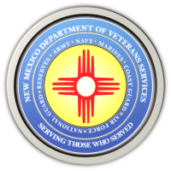
The New Mexico Department of Veterans Services

Michelle Lujan Grisham Governor
Sonya L. Smith Cabinet Secretary

Governor Michelle Lujan Grisham Tours the Angel Fire State Veterans Cemetery & Vietnam Veterans Memorial

Governor Michelle Lujan Grisham made her first official visit to the Angel Fire Veterans Cemetery and adjacent Vietnam Veterans Memorial on June 28.

The governor was greeted at the cemetery by New Mexico Department of Veterans Services Secretary (DVS) Sonya Smith, Deputy Secretary Bryan Osterhage, State Benefits Director Ed Mendez, and cemetery staff…before heading up the hill to tour the Memorial.

Here is a link to a video recap of the governor’s visit—which also contains information about a fundraising effort by Vietnam Veterans of America/Northern New Mexico Chapter 996 to raise money to help with construction of a replica Vietnam Veterans Memorial Wall at the site:
https://www.youtube.com/watch?v=XQJjguDqC7A

###

