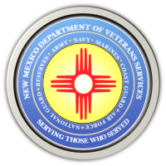
The New Mexico Department of Veterans Services

Michelle Lujan Grisham Governor
Sonya L. Smith Cabinet Secretary

Memorial Day Video Now Posted on the DVS Website

The video of the 2021 Memorial Day ceremony at the Vietnam Veterans Memorial in Angel Fire is now posted on the DVS website. Here is the link:
https://youtu.be/m3EtqNzYBVI

The video begins with a brief Memorial Day message from DVS Secretary Sonya L. Smith…which is then followed by video highlights of the ceremony.

###

