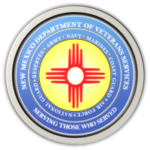
The New Mexico Department of Veterans Services

Michelle Lujan Grisham Governor
Sonya L. Smith Cabinet Secretary

“I Am Not Invisible” Video Featuring New Mexico Women Veterans Now On DVS Website

The New Mexico Department of Veterans Services (DVS) has produced a short video to help commemorate Women Veterans Day on June 12.
“I Am Not Invisible” features women veterans from New Mexico who emphatically refute the notion held by many Americans, including many women veterans themselves, that women who served in the military are not “veterans.”
Here is the link: https://www.youtube.com/watch?v=q3vhWVljaok

###

