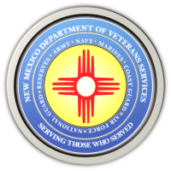
The New Mexico Department of Veterans Services

Michelle Lujan Grisham Governor
Sonya L. Smith Cabinet Secretary

State Announces On-Site COVID-19 Vaccination Events for Organizations

SANTA FE--The New Mexico Department of Health (DOH) on Tuesday announced that businesses, nonprofits, religious congregations, community centers, and other organizations can now request on-site vaccination events through a new DOH webform at https://vaccinenm.org/vaccination-site-request-form.html.

“DOH is committed to making vaccine available to New Mexicans where they live and work,” said Cabinet Secretary Dr. Tracie Collins. “By offering organizations the opportunity to request on-site vaccination events, we’ll make getting a shot even easier.”

Organizations that can bring a minimum of 25 people to a vaccination event--through a combination of employees/members, family, or members of the surrounding community--will qualify, and DOH will work with the organization on scheduling.

In some cases, DOH may combine multiple requests and create a single event in a given geographical location. DOH may also redirect requesting organizations to pre-existing events.

New Mexicans can also continue to register and self-schedule their vaccine appointments at https://vaccinenm.org.
###

