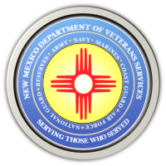
The New Mexico Department of Veterans Services

Michelle Lujan Grisham Governor
Sonya L. Smith Cabinet Secretary

DVS Produces Video Showing Step-By-Step Process For Filling Out Veterans Property Tax Exemption & Waiver

With deadlines coming up for filing property taxes in counties throughout the state, the New Mexico Department of Veterans Services (DVS) has created a video showing the step-by-step process for filling out the paperwork.
Here is the link to the video:
https://youtu.be/xoHNpvzwU_E

###

