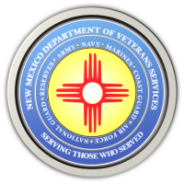
The New Mexico Department of Veterans Services

Michelle Lujan Grisham Governor
Sonya L. Smith Cabinet Secretary

Booth/Table Online Registration Now Open for
Military & Veterans Day at the State Fair (Sept. 14)

Registration is now open for table and booth space for 2021 Military & Veterans Day at the State Fair on September 14 at the state fairgrounds in Albuquerque.

Veterans or community service organizations can register online for a space along “Main Street” by going to the following website: https://statefair.exponm.com/p/things-to-do/mainstreet/application-sept-14.

The deadline to register is Monday, August 16, at 5pm.

There is a limited amount of space allotted for displays on Main Street. Applications will be selected at random to ensure an equal chance for all applicants. Organizations that are selected will be notified by email.

Military & Veterans Day at the State Fair
Military & Veterans Day at the State Fair is the annual day during the state fair presented by the New Mexico Department of Veterans Services, the New Mexico National Guard, and the New Mexico State Fair to honor and thank the men and women who have served our country as members of the United States Armed Forces.

Free admission for the day will be given to veterans, national guard/reserve personnel, and retirees who present either a valid Uniformed Services Retiree Identification Card, a veterans-designation driver’s license, VA Veterans Health ID Card (VHIC), or a copy of their DD-214 Separation Papers at the front gate. Active-duty personnel must show a valid Uniformed Services ID card for the free admission.

Non-veteran/non-military spouses or family members are not eligible for the free admission.

###

