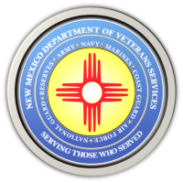
The New Mexico Department of Veterans Services

Michelle Lujan Grisham Governor
Sonya L. Smith Cabinet Secretary

DVS to Present Quarterly Briefing in Albuquerue on August 6

ALBUQUERQUE-- The New Mexico Department of Veterans Services (DVS) invites commanders, presidents, and representatives of veterans and community service organizations—as well as and any interested veteran--to a DVS quarterly briefing on August 6 at 9am at the New Mexico Veterans Memorial in Albuquerque.
The briefing will be in the indoor meeting room at the Memorial, which is located at 1100 Louisiana Blvd. SE.

DVS Secretary Sonya L. Smith and other DVS staff will provide an update on agency goals, plans, and news—along with information on other veteran-related issues.

In addition to being a great opportunity to be updated on veterans’ issue, the briefing also provides an excellent networking opportunity for New Mexico’s veteran community.

For more information, contact DVS Executive Administrative Assistant Shannon Quintana at shannon.quintana@state.nm.us or (505) 827-6334.

###

