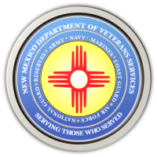
The New Mexico Department of Veterans Services

Michelle Lujan Grisham Governor
Sonya L. Smith Cabinet Secretary

DVS Wraps Up Two-Week Curbside Property Tax Certificate
Drive-Up Service in Albuquerque

The New Mexico Department of Veterans Services (DVS) wrapped up a two-week daily drive-up property tax certificate service today at its Albuquerque northeast heights office.

520 veterans and unmarried widows of veterans took advantage of this unique “carhop-style” curbside assistance by DVS staff with filing for the veterans property tax exemption or waiver, which are available for veterans or unmarried widows of veterans.

The property tax exemption is a $4,000 reduction off the taxable value of the veteran’s primary residence. The property tax waiver is available for veterans rated by the VA as 100% service-connected permanent-and-total disabled.

DVS staff wore safety masks due to COVID-19 public safety concerns. It took an average of 15-minutes for staff to verify and process the applications inside the DVS office. A property tax exemption or waiver certificate of eligibility was then brought out to the veteran or widow for them to give to their county assessor’s office to complete the process.

“We were pleased to provide this safe, quick and easy process over the course of the past two weeks,” said DVS Secretary Sonya L. Smith, who stopped by to greet veterans and thank them for their military service. “The response we received was overwhelmingly positive. Everyone who stopped by really appreciated the convenience of the service we provided.”

Throughout the year, veterans or unmarried widows of veterans can stop by any DVS office to apply for the exemption or waiver. However, during the COVID-19 pandemic, DVS staff have been working remotely via phone, email, or mail—with DVS mailing the certificate within 5-10 business days.

“I think this is great. I was surprised that it didn’t take very long,” said retired U.S. Army Col. Guy Griffin, who applied for the exemption. “They said ‘Hey, come on down. We’ll do it right at the curb—and here I am. Now I still have time to get over to the county assessor.”

“This is awesome. I’ve kinda been putting it off. I tried to look into it…what all had to be done to get this, said retired Army Sgt. 1st Class Scott Defrates. “During the pandemic, I thought I’d have to wait a couple of weeks or longer to get my certificate. To be able to come here and get it all done all in one place, is a huge benefit.”

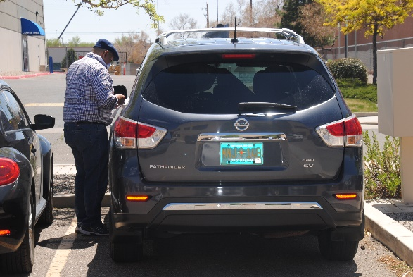
PHOTOS: DVS Veterans Service Officer George Vargas (left photo) was among DVS staff assisting veterans with filing for the veterans property tax exemption or waiver.
DVS Field Operations Director Larry Campos (right photo) checked temperatures using a digital temporal thermometer.

###

