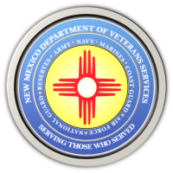
The New Mexico Department of Veterans Services

Michelle Lujan Grisham Governor
Sonya L. Smith Cabinet Secretary-Designate

FOR IMMEDIATE RELEASE
Contact: Ray Seva
Public Information Officer
ray.seva@state.nm.us
(505) 362-6089 mobile phone

December 17, 2020

DVS to host a Suicide Prevention Awareness
Facebook Live Discussion

SANTA FE-The New Mexico Department of Veterans Services (DVS) is hosting a live Facebook discussion on Suicide Prevention Awareness tomorrow (Friday, December 18) at 10am.

This discussion can be found at https://www.facebook.com/nmdvshealthcare2015.

DVS Healthcare Division Director Jemia Warner and New Mexico VA Health Care System (NMVAHCS) Suicide Prevention Case Manager Christina Camacho will discuss services provided for at-risk veterans through the NMVAHCS Suicide Prevention Program. They will also have information about other local and national suicide prevention resources available for at-risk veterans, their families, friends, co-workers, and other support-system members. For those unable to log on, a video will be posted on the DVS Facebook page shortly after the conclusion of the discussion.

###

