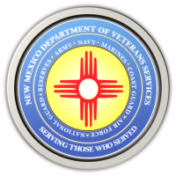
The New Mexico Department of Veterans Services

Michelle Lujan Grisham Governor
Sonya L. Smith Cabinet Secretary-Designate

FOR IMMEDIATE RELEASE
Contact: Ray Seva
Public Information Officer
ray.seva@state.nm.us
(505) 362-6089

December 22, 2020

Two Informational Videos About Veteran Suicide Awareness and Prevention Now on DVS Website

SANTA FE-The New Mexico Department of Veterans Services (DVS) has posted two videos on its website with information about veteran suicide awareness and prevention.

One of the videos is the recorded Facebook “live” discussion on December 18 between DVS Healthcare Division Director Jemia Warner and New Mexico VA Health Care System (NMVAHCS) Suicide Prevention Case Manager Christina Camacho.

The second shorter video has information covered in the videotaped discussion, and more about immediate and long-term resources available for veterans at risk for suicide.

The videos can be found at http://www.nmdvs.org/ and then scrolling down the page.

###

